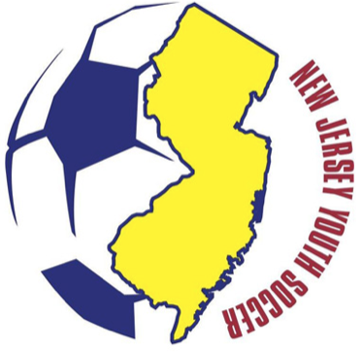
New Jersey Youth Soccer

Concussion Awareness Club Certification

Club Name: ________________________________________

Club Number: _______________________

Concussion Awareness Program Coordinator:

Name: ________________________________

Address: _____________________________________________

Town: ___________________________ State: ______ Zip: ________________

Phone: __________________________

I certify that the club named above has reviewed the certificate of completion from one of the NJYS identified Concussion Awareness online training courses for every coach associated with our organization.

Individuals who receive an NJYS Coach Pass are exempt from this requirement because they certify completing their online training during the application process.

____________________________________ _______________________
Signature Date

Attach a list of names of every coach for which you reviewed the Certificate of Completion in Concussion Awareness.

THIS FORM MUST BE RECEIVED IN THE NJYS OFFICE BY OCTOBER 15TH EACH YEAR. FAILURE TO COMPLY MAY PLACE YOUR CLUB “NOT IN GOOD STANDING” WITH NJ YOUTH SOCCER.

